**Chapter 4**

**Differentiation of Functions of Several Variables**

**4.4 Tangent Planes and Linear Approximations**

**Section Exercises**

**For the following exercises, find a unit normal vector to the surface at the indicated point.**

1. 

Answer: 

1.  when 

Answer: 

**For the following exercises, as a useful review for techniques used in this section, find a normal vector and a tangent vector at point*.***

1. 

Answer: Normal vector: , tangent vector: 

1. 

Answer: Normal vector:  tangent vector: 

1. 

Answer: Normal vector:  tangent vector: 

1. 

Answer: Normal vector:  tangent vector: 

1.  

Answer: 

**For the following exercises, find the equation for the tangent plane to the surface at the indicated point. (*Hint:* Solve for  in terms of  and **

1. 

Answer: 

1. 

Answer: 

1. 

Answer: 

1. 

Answer: 

1.  

Answer: 

1. 

Answer: 

1. 

Answer: 

1. 

Answer: 

1. 

Answer: 

1. 

Answer: 

1. 

Answer: 

1. 

Answer:

**For the following exercises, find parametric equations for the normal line to the surface at the indicated point. (Recall that to find the equation of a line in space, you need a point on the line,  and a vector  that is parallel to the line. Then the equation of the line is **

1. 

Answer: 

1. 

Answer: 

1. 

Answer: 

1. 

Answer: 

1. 

Answer: 

1.  at point 

Answer:

**For the following exercises, use the figure shown here.**

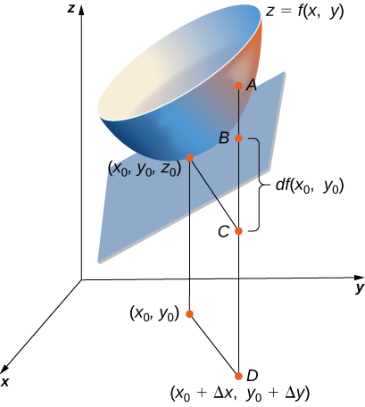

1. The length of line segment is equal to what mathematical expression?

Answer: 

1. The length of line segment  is equal to what mathematical expression?

Answer: The differential of the function 

1. Using the figure, explain what the length of line segment represents.

Answer: The length of line segment represents the difference between the actual change of the function and the approximate change in the function from  to 

**For the following exercises, complete each task.**

1. Show that  is differentiable at point 

Answer: Using the definition of differentiability, we have 

1. Find the total differential of the function 

Answer: 

1. Show that  is differentiable at every point. In other words, show that where both  and  approach zero as  approaches.

Answer:   for small  and satisfies the definition of differentiability.

1. Find the total differential of the function  where  changes from  and  changes from 

Answer: 

1. Let  Compute  from  to  and then find the approximate change in  from point  to point*.* Recall  and  and  are approximately equal.

Answer:  and  They are relatively close.

1. The volume of a right circular cylinder is given by  Find the differential  Interpret the formula geometrically.

Answer:  The change in the volume is composed of two parts. The first part is the surface area of the cylinder multiplied by the change in the radius. The second part is the area of the two circular surfaces (top and bottom of the cylinder) multiplied by the change in height.

1. See the preceding problem. Use differentials to estimate the volume of aluminum in an enclosed aluminum can with diameter  and height  if the aluminum is  cm thick.

Answer:  cm3

1. Use the differential  to approximate the change in  as  moves from point  to point  Compare this approximation with the actual change in the function.

Answer:   actual change 

1. Let . Find the exact change in the function and the approximate change in the function as  changes from  and  changes from

Answer:  exact change  approximate change is  The two values are close.

1. The centripetal acceleration of a particle moving in a circle is given by  where  is the velocity and  is the radius of the circle. Approximate the maximum percent error in measuring the acceleration resulting from errors of  in  and  in  (Recall that the percentage error is the ratio of the amount of error over the original amount. So, in this case, the percentage error in  is given by 

Answer: 

1. The radius  and height  of a right circular cylinder are measured with possible errors of  respectively. Approximate the maximum possible percentage error in measuring the volume (Recall that the percentage error is the ratio of the amount of error over the original amount. So, in this case, the percentage error in  is given by 

Answer:

1. The base radius and height of a right circular cone are measured as  in. and  in., respectively, with a possible error in measurement of as much as  in. each. Use differentials to estimate the maximum error in the calculated volume of the cone.

Answer: The maximum error in the calculated volume of the cone is about 

1. The electrical resistance  produced by wiring resistors  and  in parallel can be calculated from the formula  . If  and  are measured to be  and  respectively, and if these measurements are accurate to within  estimate the maximum possible error in computing (The symbol  represents an ohm, the unit of electrical resistance.)

Answer:

1. The area of an ellipse with axes of length  and  is given by the formula

 Approximate the percent change in the area when  increases by  and  increases by 

Answer: 

1. The period  of a simple pendulum with small oscillations is calculated from the formula  where  is the length of the pendulum and  is the acceleration resulting from gravity. Suppose that  and  have errors of, at most,  and  respectively. Use differentials to approximate the maximum percentage error in the calculated value of 

Answer: 

1. Electrical power  is given by where  is the voltage and  is the resistance. Approximate the maximum percentage error in calculating power if   is applied to a  resistor and the possible percent errors in measuring  and  are  and respectively.

Answer: 

**For the following exercises, find the linear approximation of each function at the indicated point.**

1. 

Answer: 

1. 

Answer: 

1. 

Answer: 

1. 

Answer: 

1. 

Answer: 

1. **[T]** Find the equation of the tangent plane to the surface  at point  and graph the surface and the tangent plane at the point.

Answer: Tangent plane:

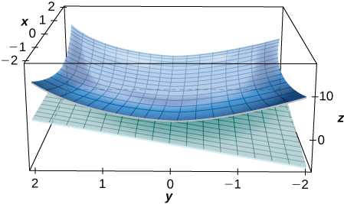

1. **[T]** Find the equation for the tangent plane to the surface at the indicated point, and graph the surface and the tangent plane: 

Answer: 

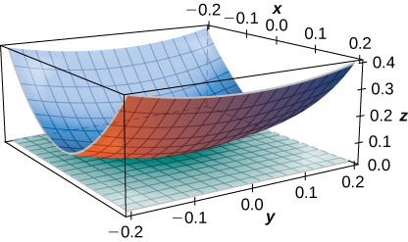

1. **[T]** Find the equation of the tangent plane to the surface  at point  and graph the surface and the tangent plane.

Answer: 

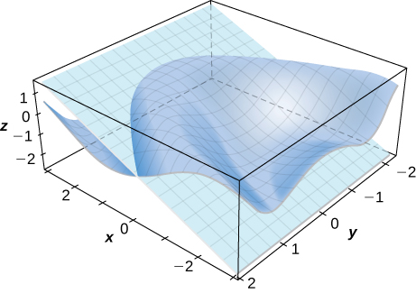

This file is copyright 2016, Rice University. All Rights Reserved.